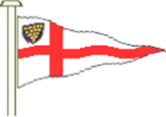
MYLOR YACHT CLUB – APPLICATION FOR A MYC MOORING

- I/we wish to apply for a Mylor Yacht Club (“MYC”) mooring. Our details are as follows:

Name:

Email address:

Telephone No:

Address:

Are you a Club Member (yes/no):

Boat Name:

Type of Boat:

Boat Name:

LOA (feet):

Draught:
(Note the LAT around the Fundus is 1.6m)
Vessel Displacement:

- Thank you for your application and we hope to get back to you quickly. Your application takes effect on the waiting list from the date of receipt. Please feel free to contact us about mooring availability at any time.

- GDPR Notice. All mooring administration is undertaken electronically and it is a condition of holding a Club mooring that you consent to MYC Ltd holding your personal information electronically and that you have an active email account.

Mylor Yacht Club Moorings Officer
Email: moorings@myloryachtclub.org.uk

